Review article:
Nanodentistry - An interdisciplinary kaleidoscope
¹Dr Yati Mehta , ²Dr Jitiksha Dhodi , ³Dr Renuka Patel, ⁴Dr Falguni Mehta

Department of Orthodontics & Dentofacial Orthopedics, Government Dental College and Hospital, Ahmedabad, Gujarat, India.
Corresponding author : Dr Jitiksha Dhodi

Abstract:
With the increasing demand for advances in diagnosis and treatment modalities, nanotechnology is being considered as a ground breaking and viable research subject. It deals with the physical, chemical, and biological properties of structures and their components at nanoscale dimensions. It is based on the concept of creating functional structures by controlling atoms and molecules on a one-by-one basis. Nanotechnology has toppled the world, revolutionizing almost every field such as biology, physics, chemistry, mathematics, engineering, industry, medicine, pharmacology, dentistry, and many more. The “Maxwell’s demons” as the nanoparticles were called earlier, have helped humankind in achieving profound effects by manipulation of the materials in the nanoscale. The day may soon come when nanodentistry will succeed in maintaining near-perfect oral health through the aid of nanorobotics, nanomaterials and biotechnology. However, as with all developments, it may also pose a risk for misuse. Time, economical and technical resources, and human needs will determine the direction this revolutionizing development may take.
Key words: Nanotechnology, dentistry, Nanorobotics.
Introduction:
Science is currently undergoing a major development that is leading humanity into a new era: the era of nanotechnology. The prefix 'nano' is derived from a Greek prefix meaning 'dwarf' or something very small denoting one thousand millionth of a meter (10⁻⁹ m). There is difference between nanoscience and nanotechnology.¹ Nanoscience is the study of structures and molecules at nanometer scale between 1 and 100 nm, and the technology that applies it to practical applications such as devices etc. is called nanotechnology. For comparison, it is necessary to realize that a single human hair is 60,000 nm thick and the DNA double helix has a radius of 1 nm.¹ Nanotechnology can be defined as a technology that deals with small structures or materials of small size. Prof Keric E Dexler, an expert in the field of nanotechnology, coined the term nanotechnology. The development of nanoscience can be traced back to the time of the Greeks and Democritus in the 5th century B.C., when scientists were concerned with the question of whether matter is continuous, and thus infinitely divisible into smaller pieces, or consists of small, indivisible and indestructible particles, which scientists today call atoms. ^{1,2,3} The goal of nanotechnology is to enable the analysis of nanoscale structures, to understand the physical properties of nanoscale structures, to fabricate nanoscale structures, to develop devices with nanoprecision, and to establish a link between the nanoscopic and macroscopic universe by developing appropriate methods.⁴
The pioneers of nanotechnology:
American physicist and Nobel Prize winner Richard Feynman introduced the concept of nanotechnology in 1959. During the annual meeting of the American Physical Society, Feynman gave a lecture at the California Institute of Technology (Caltech) entitled "There's Plenty of Room at the Bottom" Technology (Caltech)⁵. In this lecture, Feynman hypothesized, "Why cannot we write the entire 24 volumes of the Encyclopedia Britannica on the head of a pin?" and described the vision of using machines to construct smaller machines, down to the molecular level. This new idea proved Feynman's hypotheses correct, which is why he is considered the father of modern nanotechnology.⁵ Fifteen years later, Norio Taniguchi, a Japanese scientist, was the first to use the term "nanotechnology" in 1974, defining it as "nanotechnology consists mainly of the separation, consolidation and deformation of materials by an atom or a molecule".⁶ In 2000, R.A. Freitas Jr. coined the term "nanodentistry". He envisioned the future applications and developments of nanoscience in various fields of dentistry, such as nanorobotics in the induction of anesthesia, tooth repair, treatment of tooth hypersensitivity, dental esthetics, tooth repositioning, and periodontal disease etc.^{7,8}
Nanodentistry
Nanotechnology has conquered conventional techniques in local anesthesia, drug delivery, restorative materials, cosmetic dentistry - durability and esthetics of teeth, treatment of hypersensitivity, correction of malpositioned teeth, dentures-dental prosthesis and implant materials, impression materials, surgical nanoinstruments - needles and forceps, dentifrices, LASER plasma, bone substitutes, sterilization products, tissue engineering, digital imaging, screening and diagnosis of oral tumors.⁷
The powerful technologies that serve as tools for nanodentistry are as follows:
- Nanomaterials in advanced diagnostics, biosensors, targeted drug delivery, and smart drugs;
- Genomics, proteomics, and biobotics (artificial nanorobots)
- Future prospects such as theranostics, tissue engineering, magnetofection, regenerative medicine, and gene therapy.⁷

Approaches to nanodentistry
Bottom-up approaches
- Assembly of small components into composite structures.^{9,10}
Top-down approaches
- Creation of smaller structures using larger structures as a guide for their assembly.^{9,10}

Nanotechnology in oral medicine and radiology
Dental caries and periodontal diseases are among the most common human diseases.The oral cavity is frequently afflicted by autoimmune disorders and carcinomatous changes.⁹ Highly sensitive diagnostic techniques that allow better detection of autoantibodies, dysplastic cells, and salivary biomarkers are needed for accurate diagnosis and early treatment. Cost-effective technological advances in this area will help ensure a widespread implementation of salivary diagnostics. The Oral Fluid Nano Sensor Test (OFNASET, The Wong Lab, University of California, Los Angeles) is a highly sensitive, specific, portable, and automated nanoelectromechanical system that enables point-of-care detection of salivary proteomic biomarkers and nucleic acids specific for oral cancer, including 4 mRNA biomarkers (SAT, ODZ, IL-8, and IL-1β) and 2 proteomic biomarkers (thioredoxin and IL-8).¹¹ The various nanostructures employed in nanodiagnostics include quantum dots, nanoscale cantilevers, nanopores, nanotubes, and gold nanoparticles. They have paved the way for a new field called theranostics by serving diagnostic and therapeutic purposes simultaneously.¹²

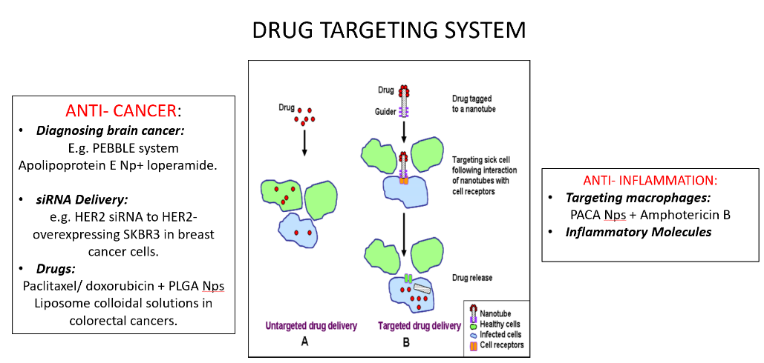
TARGETED AND UNTARGETED DRUG DELIEVERY SYSTEM

Nanostructures used in nanodiagnostics:
- nanoscale cantilevers
- nanopores
- nanotubes
- gold nanoparticles.⁹

Nanotechnology in orthodontics:
Studies of orthodontic brackets and archwires using nanoindentation and atomic force microscopy show that the surface properties, i.e., roughness and surface free energy (SFE), of the brackets play an important role in reducing friction and plaque formation. Minimizing the frictional forces between the orthodontic wire and the brackets has the potential to enhance the desired tooth movement and thus shorten the treatment time, for which nanoparticles were used as a component of dry lubricants. Inorganic fullerene-like nanoparticles of tungsten sulfide (IF -WS2), which are effective dry lubricants, have been used as self-lubricating coatings for stainless steel orthodontic wires.¹³
Elastomeric ligatures can serve as a carrier material for nanoparticles that can be embedded in the elastomer matrix as anticariogenic, anti-inflammatory, and antibiotic drug molecules.
Nanoelectromechanical systems (NEMS) are devices that integrate electrical and mechanical functions at the nanoscale. There is evidence that orthodontic tooth movement can be improved by supplementing mechanical forces with electricity.¹³
Biocompatible coatings such as titanium nanotubes should be investigated to determine if the nanotube-shaped layer can improve initial osseointegration and serve as a boundary layer between the newly formed bone and the TAD.¹³
Smart Brackets:
Recently, the concept of a smart bracket with an integrated sensor system for 3D force and moment measurement has been published. Nanomechanical sensors can be fabricated and integrated into the base of orthodontic brackets to provide real-time feedback on the applied orthodontic forces.¹³
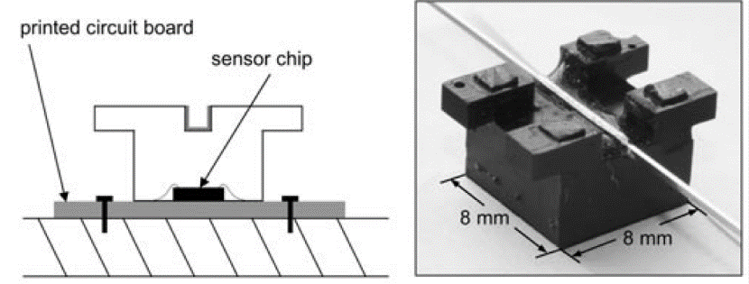
This real-time feedback allows the orthodontist to adjust the applied force so that it is within a biological range to move teeth efficiently and with minimal side effects. Lapaki et al. reported on the introduction of a "smart" brackets for multidimensional force and moment control.¹⁴

Nano-composites:
Polymer nanocomposites are a new class of materials that contain nanofillers ranging in size from 0.005 to 0.01 micrometers. Geraldeli and Perdigao reported that nanocomposites have a good marginal seal to enamel and dentin compared with total-etch adhesives. The advantages of nanocomposite materials include excellent optical properties, ease of handling, and excellent polishability.
In addition, nanofillers can reduce the surface roughness of orthodontic adhesives, which is one of the most important factors for bacterial adhesion.^{4,9,10}
Research has been done between a nano-composite (Filtek Supreme Plus Universal) and a nano-ionomer (Ketac ™ N100 Light Curing Nano-Ionomer) to determine shear bond strength (SBS) and failure sites compared to a conventional light-curing orthodontic adhesive (Transbond XT). The results suggest that nanocomposites and nano-ionomers may be suitable for bonding, as they achieve the previously proposed SBS ranges for clinical acceptability. However, they are inferior to a conventional orthodontic composite. ^{4,9,10}

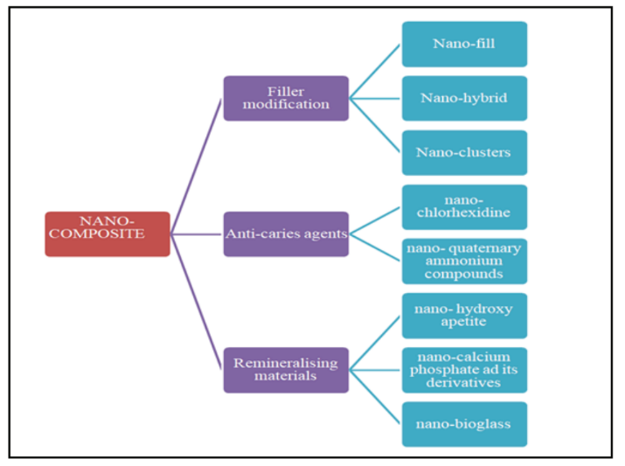

Nanotechnology in periodontology
Quantum dots (QDs) in combination with immunofluorescence help in the precise labelling of specific periodontal pathogens, enabling the unequivocal diagnosis of periodontal diseases. Lead-free and cadmium-free quantum dots are used in periodontal therapy to promote healing of inflamed tissues. Their photosensitizing property has wide-ranging applications in cancer treatment, tumor localization, margin detection, identification of important adjacent structures, sentinel lymph node mapping, and micrometastases detection.^{9,15}

Nanotechnology for Preventive Dentistry
In the sphere of preventive plaque control measures, dentifrices and mouthwashes are most commonly used products. Dentifrices can be infused with specific active ingredients that help prevent caries, remineralize early carious lesions, and aid in desensitization of abraded teeth.⁹ Nanosized calcium carbonate particles or hydroxyapatite crystals resemble the morphology and crystal structure of enamel.¹² In a study using a test dentifrice containing nanosized calcium carbonate particles, Nakashima et al found 48.8% improvement in the remineralization of artificially produced subsurface enamel lesions.¹⁶ Nano-calcium fluoride, for instance, has been added to mouth rinses to decrease caries activity, reduce dentine permeability, and increase labile fluoride concentration in oral fluid (Sun and Chow, 2008). Dentifrices for dental hypersensitivity containing nanohydroxyapatite (n-HAP) or nanocarbonate apatite (n-CAP) particles are currently being tested. n-CAP resembles to the inorganic component of teeth and is known to have high solubility and a more neutral pH.¹⁷ Mouthwashes containing nanoparticles loaded with triclosan and silver nanoparticles have demonstrated their potential for plaque control. The colloidal suspensions of triclosan nanoparticles have shown high substantivity due to the use of bioadhesive polymers in the system.¹⁸ The technology is based on a polyanhydride bioadhesive nanoparticulate platform that provides high mucoadhesive capacity for 8 hours, increased encapsulation capacity, more homogeneous particle size (250 nm), and a longer shelf life (2 years).¹⁹ Mouthwashes containing biomimetic carbonate-hydroxyapatite nanocrystals have been shown to preserve the titanium oxide layer of the by protecting it from surface oxidative processes. These nanocrystals also reduce implant surface roughness by depositing hydroxyapatite in the striations on the titanium surface. This reduction in surface roughness provides better prevention against plaque accumulation and peri-implant pathologies.
Researchers developed a nano toothbrush, by incorporating colloidal nanogold or nanosilver particles between the bristles of the toothbrush (Raval et al., 2016). In addition to their ability to improve mechanical plaque removal, the researchers reported an antibacterial effect of the added gold or silver which could ultimately lead to a significant reduction in periodontal disease.²⁰
Nanotechnology in prosthodontics:
The incorporation of 0.4% TiO2 nanoparticles into a 3D-printed polymethyl methacrylate (PMMA) denture base was investigated in 2017 to improve its antibacterial properties and mechanical properties (Totu et al., 2017).Researchers also studied the tribological behaviour of a thermoset PMMA modified with 7 wt% nano-zirconia (Ahmed and Ebrahim, 2014).²⁰ The addition of zirconia nanoparticles significantly improved the hardness, flexural strength, and fracture toughness of the heat-cured PMMA denture base. The nano- sized fillers were used due to their excellent dispersion properties, lower aggregation potential and biocompatibility with the organic polymer. Nano-zirconium improved the physical properties of denture bases during the construction phase and also the transverse strength of a repaired denture base (Gad et al., 2016).²⁰ Solutions of chlorhexidine mixed with sodium triphosphate (TP), trimetaphosphate (TMP), or hexametaphosphate (HMP) were found to enhance the antifungal properties of a chlorhexidine coating with a series of nanoparticle additives [such as sodium triphosphate (TP), Trimetaphosphate (TMP), or hexametaphosphate (HMP)] have been used to inhibit fungal infections in dental silicones commonly used as denture softliners and obturators. Luting cements impregnated with nanoparticles were found to be significantly effective in increasing bond strength to enamel and dentin compared to conventional luting cements.
Nanotechnology in restorative dentistry
Nano-fillers reduce polymerization shrinkage and thermal expansion and improve polishability, hardness and wear resistance of composites.²¹ The size of these particles ranges from 0.005-0.01 μm Two different types of nanofillers have been synthesised: Nanomers (5-75 nm) and nanoclusters (2-20 nm). Their incorporation into an existing resin matrix system has been shown to improve the optical and polishing properties of microfiller composites and the strength of hybrid composites.²¹ Incorporation of nano-filled resins into self-adhesive GIC coatings for posterior restorations has also demonstrated high hydrophilicity and protection against abrasive wear.^{22,23} Nanosilver particles were incorporated into a gel matrix and used as a root canal sealant. However, this nanosilver gel proved less efficient than chlorhexidine and triple antibiotic paste in inhibiting the spread of Enterococcus faecalis.
Digital radiography and micro-computed tomography images showed that obturation with a conventional technique using nanodiamond-impregnated GP had better chemical properties, biocompatibility, and mechanical properties.²⁴ The incorporation of cross-linked quaternized polyethyleneimine nanoparticles (QPEI) in resin composites has also been reported to have antibacterial effects against various oral pathogens, such as Enterococcus faecalis, Streptococcus mutans, Actinomyces viscousus, Lactobacilus casei, and total saliva.²⁴ Bioceramic-based nanoparticles incorporated into endodontic sealants have revolutionised obturation by gaining access to irregular dentin surfaces .Tooth whitening agents have been additionally nano-modified to increase their bleaching efficacy and minimise their harmful side effects. The inclusion of Nano-Lipobelle H-EQ10 in the bleaching agent significantly improved the chemical and mechanical condition of the whitened enamel. Nano-Lipobelle H-EQ10 are liposomes loaded with 10% vitamin E and 5% coenzyme.²⁴

Regenerative dentistry
This includes:
- Tissue engineering
- Bone Grafting
- Guided tissue regeneration
- Nerve regeneration
- Pulp Regeneration
Tissue Engineering:
Potential applications of tissue engineering and stem cell research in dentistry include treatment of facial fractures, bone augmentation, cartilage regeneration of the temporomandibular joint, pulp repair, periodontal ligament regeneration, and osseointegration of implants.^{.4} Nanoscale fibers have a similar shape to the arrangement of collagen fibrils and hydroxyapatite crystals in bone. Studies conducted in recent years indicate that nanoparticles can be used to improve the mechanical properties of these materials. The main reason for the preference of nanoparticles is that the size range of these structures corresponds to that of cellular and molecular components.⁹ Gene-activated matrix (GAM) provides a platform for combining tissue engineering and local gene transfer systems in periodontal tissue regeneration. The most recent development in this area is a GAM, which consists of a chitosan/collagen scaffold that acts as a three-dimensional carrier and incorporates chitosan/plasmid nanoparticles encoding platelet-derived growth factor.^{9,25}
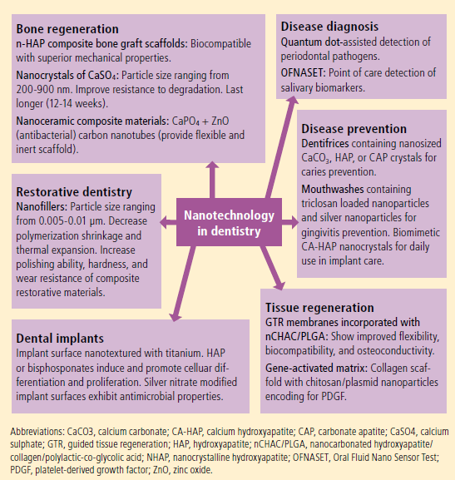
Bone grafting: At the same time, artificial bone graft substitutes have been developed to avoid the disadvantages of second-site surgery and inconsistent graft volume. The most popular are nanoHAP (n- HAP) bone grafts, which are available in crystalline, chitosan-associated, and titanium-reinforced forms.²⁶These n- HAP composite bone grafts are highly biocompatible, have superior mechanical properties, and elicit better cellular responses compared to "normal" chitosan scaffolds.^{27,28} Conventional CaSO4 bone grafts have now evolved into nanosized crystals with particulate sizes ranging from 200 900 nm. These nanoparticles are further compacted into pellets of 425-1000 μm. This nanotization of the particles results in a graft material that is more resistant to degradation and lasts longer (12-14 weeks). Recently, an antibacterial nanoceramic composite material was developed by impregnating nanocalcium phosphate, carbon nanotubes, and zinc oxide (ZnO) nanoparticles into an alginate polymer matrix. Current research is focused on the fabrication of nanoparticle composites and nanofibers to increase mechanical strength and support cell growth and differentiation in required bone structures. Genetic material transport systems encoding osteogenic growth factors are also being developed.²⁹

Guided tissue regeneration:
A novel system was developed using a three-layer GTR membrane consisting of an innermost layer of 8% porous membrane of nanocarbonated hydroxyapatite/collagen/polylactate coglycolic acid (nCHAC/PLGA), a middle layer of 4% nCHAC/PLGA, and an outer layer of nonporous PLGA membrane. Together, these three layers form a highly flexible, biocompatible, osteoconductive, and biodegradable composite membrane. When osteoblastic cells were cultured on this membrane, they showed a more positive response compared to a pure PLGA membrane.⁹

Nerve Regeneration:
Nanoparticles can also be used to reconstruct damaged nerves, using self-aggregating rod-shaped nanofibers called amphiphiles. Aggregated amphiphiles can reach a length of up to several micrometers and can be used in vivo to bridge tissue defects in the spinal cord.³⁰

Pulp regeneration:
The α-melanocyte-stimulating hormone (α -MSH) is known for its anti-inflammatory properties. Recently, it has been suggested that nanofilms containing a-MSH may help revitalize damaged teeth. Further research is needed to evaluate these proposed therapeutic and regenerative approaches.³¹

Nanotechnology & Dental Implants:
Surface characteristics determine the biocompatibility and biointegration of implants by regulating their surface energy, composition, roughness, and topography.³² Titanium implants coated with a nanostructured calcium coating were placed in the tibia of rabbits, and their effect on osteogenesis was studied; the nanostructured calcium coating increased the responsiveness of the bone around the implant.⁹
Numerous in vitro studies have shown that the nanotopography of the implant surface has a significant effect on osteogenic cells and that the nanoscale surface morphology improves osteoblast adhesion.⁹ Implants coated with nanotextured titanium, hydroxyapatite, or pharmacological agents such as bisphosphonates can induce and promote cell differentiation and proliferation. In a proposed topological modification for implants with nanodot structures, Pan et al. found that 50-nm
CIPROFLOXACIN AND GENTAMYCIN COATED HA NANOPARTICLES ELECTROPHORETICALLY DEPOSITED ON IMPLANTS

nanodots increased osteoblast cell population by 44%, minimized apoptotic cell death, and increased focal cell adhesion by 73%.³³ Recently, experiments have also been conducted to introduce antimicrobial bioactive implant surfaces. Nanostructured crystalline titanium dioxide coatings deposited with a cathodic arc exhibited UV-induced bactericidal activity against Staphylococcus epidermidis and reduced the number of viable bacteria by 90% within 2 minutes of the UV dose.³⁴

Nanotechnology in oral and maxillofacial surgery:
Selective cell manipulation and surgical intervention using molecular-level tools will be particularly useful in tumor surgery.⁴

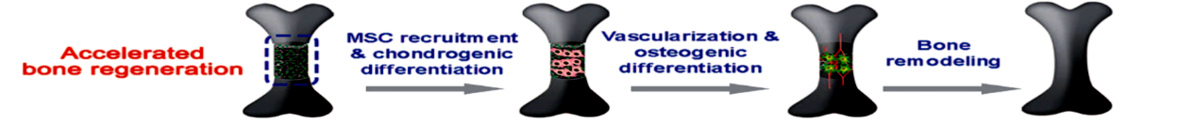
3D NANOSCAFFOLD INFILTRATED WITH Rh-BMP ACCELERATES BONE REGNERATION

Dental nanorobots:
Dental nanorobots are capable of moving through teeth and surrounding tissues using specific movement mechanisms.⁴ Nanorobots (Dentifrobots) left on the chewing surfaces of teeth by mouthwash or toothpaste can clean organic debris by moving through the supragingival and subgingival surfaces, continuously preventing tartar formation. A colloidal suspension containing millions of anesthetic dental nanorobots is used to induce local anesthesia. The nanorobots are applied to the gums, reach the dentin and move through the dentinal tubules to the pulp, guided by a nanocomputer under the dentist's control through chemical differentials, temperature gradients and position control. When they reach the pulp, the pain-relieving robots can eliminate all sensation in the tooth. Once the treatment is complete, the nanorobots can be instructed to restore all sensations and leave the tooth. This technique is beneficial because it reduces apprehension and is quick and completely reversible.¹⁰

Conclusion
Nanotechnology is a relatively new field that deals with the manipulation of matter at the molecular level, including individual molecules and the interactions between them. The focus is on positional control with a high degree of specificity leading to desired physical and chemical properties. Research to improve existing nanomaterials continues, with future direction toward more efficient and cost-effective nanobiosensors, e.g., for highly accurate diagnosis of oral cancer, and new oral drug delivery systems to interrupt biofilm formation and reduce the incidence of dental caries and periodontal disease.The current applications of nanotechnology in various areas of dentistry are highlighted here, these applications will pave the way for further research opportunities in device and drug development and usher in an era of unprecedented advances in dental diagnostics and therapeutics.

References:
- Bayda S, Adeel M, Tuccinardi T, Cordani M, Rizzolio F. The history of nanoscience and nanotechnology: from chemical–physical applications to nanomedicine. Molecules. 2019 Dec 27;25(1):112.
- Drexler KE. Engines Of Creation: The Coming Era Of Nanotechnology. New York: Anchor Press; 1986:99-129
- Cyril NG, Lung K. Where Will Nanotechnology Take us in the 21st Century? Available at: http://www.ys journal.com/temp/YoungScientissJ1634-3214608_ 085546.pdf. Accessed March 26, 2014
- Ozak ST, Ozkan P. Nanotechnology and dentistry. European journal of dentistry. 2013 Jan;7(01):145-51.
- Feynman RP. There’s plenty of room at the bottom. Eng Sci. 1960;23:22-36.
- Taniguchi N. Proceedings of the International Conference on Precision Engineering (ICPE). Tokyo, Japan. 1974:18-23
- Raju R. Nanotechnology in interdisciplinary dentistry. Indian Journal of Medical Sciences. 2021 Sep 24;73(2):226-9.
- Freitas RA Jr. Nanodentistry. J Am Dent Assoc 2000;131:1559.
- Bhavikatti SK, Bhardwaj S, Prabhuji ML. Current applications of nanotechnology in dentistry: a review. General dentistry. 2014 Jul 1;62(4):72-7.
- Bhardwaj A, Bhardwaj A, Misuriya A, Maroli S, Manjula S, Singh AK. Nanotechnology in dentistry: Present and future. Journal of international oral health: JIOH. 2014 Feb;6(1):121.
- Gau V, Wong D. Oral fluid nanosensor test (OFNASET) with advanced electrochemical-based molecular analysis platform. Ann N Y Acad Sci. 2007;1098:401-410.
- Vandiver J, Dean D, Patel N, Bonfield W, Ortiz C. Nanoscale variation in surface charge of synthetic hydroxyapatite detected by chemically and spatially specific high resolution force spectroscopy. Biomaterials. 2005;26:271-283
- Govindankutty D. Applications of nanotechnology in orthodontics and its future implications: a review. Int J Appl Dent Sci. 2015;1(4):166-71.
- Lapatki BG, Paul O. Smart backets for 3D-force-moment measurement in orthodontic research and therapy developmental status and prospects. J Orofac Orthop. 2007; 68(5)377-396
- Chalmers NI, Palmer RJ, Thumm LD, Sullivan R, Wenyuan S, Kolenbrander PE. Use of quantum dot luminescent probes to achieve single-cell resolution of human oral bacteria in biofilms. Applied Env Microbiol. 2007
- Nakashima S, Yoshie M, Sano H, Bahar A. Effect of a test dentifrice containing nano-sized calcium carbonate on remineralization of enamel lesions in vitro. J Oral Sci. 2009;51(1):69-77.
- Lee SY, Kwon HK, Kim BI. Effect of dentinal tubule occlusion by dentifrice containing nano-carbonate apatite. J Oral Rehabil. 2008;35(11):847-853.
- BioNanoPlus Drug Delivery Technologies. Antiseptic Mouthwash. Available at: http://bionanoplus.com/antiseptic-mouth-wash.html. Accessed March 26, 2014.
- BioNanoPlus Drug Delivery Technologies. NANO GES. Available at: http://bionanoplus.com/nano-ges.html. Accessed March 26, 2014.
- AlKahtani RN. The implications and applications of nanotechnology in dentistry: A review. The Saudi dental journal. 2018 Apr 1;30(2):107-16.
- Mitra SB, Wu D, Holmes BN. An application of nanotechnology in advanced dental materials. J Am Dent Assoc. 2003;134(10):1382-1390. 33. Dresch W, Volpato S, Gomes JC, Ribeiro NR, Reis A, Loguercio AD.
- Clinical evaluation of a nanofilled composite in posterior teeth: 12-month results. Oper Dent. 2006;31(4):409-417
- Vaikuntam J. Resin-modified glass ionomer cements (RM GICs) implications for use in pediatric dentistry. J Dent Child. 1997;64(2):131-134. 35. Tanaka K, Kato K, Noguchi T, Nakaseko H, Akahane S.
- Reddy S, Malarvizhi D, Venkatesh A, Vivekanandhan P. Nanotechnology and its Application in Restorative Dentistry: A Review of Literature. Indian Journal of Forensic Medicine & Toxicology. 2020 Oct 1;14(4):1215.
- Peng L, Cheng X, Zhuo R, et al. Novel gene-activated matrix with embedded chitosan/plasmid DNA nanoparticles encoding PDGF for periodontal tissue engineering. J Biomed Mater Res. 2009;90(2):564- 576.
- Singh VP, Nayak DG, Uppoor AS, Shah D. Clinical and radiographic evaluation of nano-crystalline hydroxyapatite bone graft (Sybograf) in combination with bioresorbable collagen membrane (Periocol) in periodontal intrabony defects. Dent Res J (Isfahan). 2012;9(1):60- 67.
- Design and characterization of a novel chitosan/nanocrystalline calcium phosphate composite scaffold for bone regeneration. J Biomed Mater Res. 2009;88(2):491-502. 43. Chesnutt BM, Yuan Y, Buddington K, Haggard WO, Bumgardner JD.
- Composite chitosan/nano-hydroxyapatite scaffolds induce osteocalcin production by osteoblasts in vitro and support bone formation in vivo. Tissue Eng Part A. 2009;15(9):2571-2579.
- Kim K, Fisher JP. Nanoparticle technology in bone tissue engineering. J Drug Target. 2007;15(4):241-252
- Ellis-Behnke RG, Liang YX, You SW, et al. Nano neuro knitting: peptide nanofiber scaffold for brain repair and axon regeneration with functional return of vision. Proc Natl Acad Sci U S A. 2006;103(13):5054-5059
- Fioretti F, Palomares CM, Helms M, et al. Nanostructured assemblies for dental application. ACS Nano. 2010;4(6):3277-3287.
- Nayar S, Bhuminathan S, Muthuvignesh J. Upsurge of nanotechnology in dentistry and dental implants. Indian J Multidiscipl Dent. 2011;1(5):264-269.
- Pan HA, Hung YC, Chiou JC, Tai SM, Chen HH, Huang GS. Nanosurface design of dental implants for improved cell growth and function. Nanotechnology. 2012;23(33):335703.
- Lilja M, Forsgren J, Welch K, Astrand M, Engqvist H, Stromme M. Photocatalytic and antimicrobial properties of surgical implant coatings of titanium dioxide deposited though cathodic arc evaporation. Biotechnol Lett. 2012;34(12):2299-2305.

